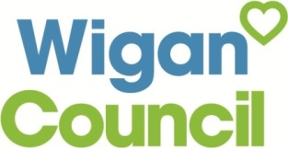
Voice of the Child/Young Person Form (Written) (AR2b)
This form can be used to gather the child/young person’s views as part of a new EHC assessment/EYAR referral, annual review or transfer review. This form (wherever possible) should reflect the views directly expressed by the child/young person and reference to how the views of the child/young person have been sought should be documented
Name |  | DOB
If I have needed help completing this form, I have been helped by… |  | Date
Setting/School I attend |  | Year group

Please consider the child’s views in school and out of school.
I will give my views in my review meeting by……

What am I good at / what are my strengths?

What do I like doing?
Who are my family and friends?

What makes me happy?

Things I enjoy most in school/setting are….

Things I find difficult in school/setting are…..

People can help me by…..

What is working well for me?

What would I like to get better at?
My aspirations / hopes: what I would like for my future (work and life).
What will help me prepare for adult life to achieve the best outcomes in employment, independent living, staying healthy participating in my community?

Anything else I would like to share/discuss as part of my review meeting…

