Essential Information
Name | ** |  |  |  |  | DoB
Gender | Male/Female |  | Ethnicity |  |  | Religion
Home Address of Child/Young Person
Postcode
Name of Parent(s)/
Carer(s)
Address
(if different from above)
Home Phone
Mobile
Email

Setting |  |  |  |  | Pupil’s UPN
Date of  Admission |  |  | Current  Yr Group |  | Home Language
Other settings attended within the last 12 months

Is the child/young person in Public Care? | Yes |  | No
Do they have a Child in Need Plan? | Yes |  | No
Do they have an EHF (CAF)? | Yes |  | No

Primary (main) category of need as defined in the Code of Practice (please tick one)
 |  | SpLD  MLD  SLD  PMLD |  |  | SLCN  ASD |  |  | SEMH |  |  | HI  VI  MSI  PD
C & L |  | SpLD  MLD  SLD  PMLD | C & I |  | SLCN  ASD | SEMH |  | SEMH | S/P |  | HI  VI  MSI  PD

Name of Child / Young Person’s GP |  | NHS No.
GP Address
Postcode

Section A Views, Interests and Aspirations
All about **

This section describes the views, interests and aspirations of the child and their parents or young person (This might include health, relationships, learning outcomes, employment, independent living, housing, community, inclusion).

It is important to be clear who’s view is being expressed whether it is the child, parent/carer or young person.

Personal Profile
Current photo of ** | What people like and admire about **
What’s important to **?

What’s important for **?
(E.g. What’s needed for ** to feel valued or for them to keep safe and well?)

Important for **’s future

Family Profile
Who is in **’s family?

Other important people

Important things to know about the family

Family resilience
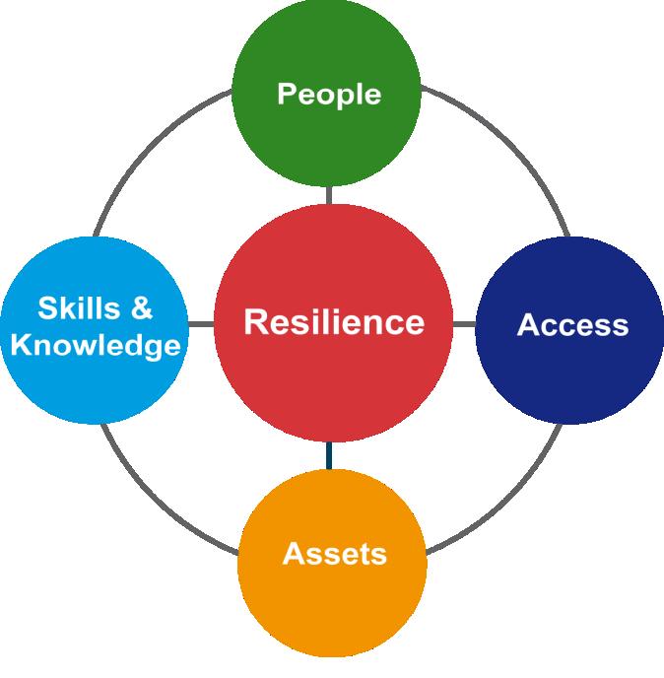 | What is the real wealth that supports the family’s resilience?  Their strengths and abilities and the human, financial and community resources that are available to them
What’s available to the family to support them?

Current Support

(Consider within Education, Health and Care as appropriate)
What is working for **?
What’s not working so well?
What do we need to do next? (Planning action/Setting outcomes)

Parents’/ Carer’s/Child’s/ Young Person’s Views and Aspirations

Summary of the views of the child or young person and their parent(s)/carer(s) about outcomes or particular concerns across Education, Health and Care.

Pupil views: (reference where views are from and how given)
Parental views: (reference where views are from)

My Aspirations (Child/Young Person)
Long Term Aspirations (Parental)

Has the family expressed an interest in a Personal Budget as part of the personalised approach? Yes No
Other comments / actions:

This section has been completed by:

Views have been collated via :

