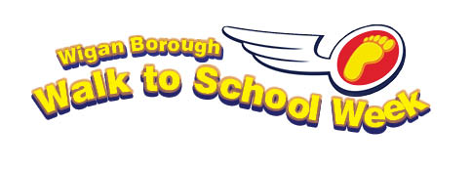

Dear parents/carers.

Walk to School Week.
Walk to School Week is taking place on the Monday______ to Friday ______. We hope you’ll join in to make this year’s event a great success. This year we are running a walk to school passport scheme. Pupils who walk to school will get a stamp in their passport.

Why walk?
There are many benefits of walking to school with your child.

- It is good for the health of both yourself and your child (regular exercise can help reduce obesity and is good for the heart, lungs and bones).
- Fewer cars on the roads and around the school gates make the area safer for those who want to walk.
- Your child can practise their road safety skills to prepare them for later life.
- It’s sociable for pupils and adults, you can meet up with others. Why not see what you can spot on the journey?
- Walking is much cheaper than coming by car.
- Children who walk to school arrive more alert and ready to learn.
- Fewer cars mean cleaner air for our children.
- Walking to school rather than coming by car is better for the environment.
- Walking is less stressful than being stuck in traffic and trying to find somewhere to park.
- Walking to school can actually be quicker!

Don’t forget your raincoat!
If it rains during Walk to School Week don’t forget your raincoat and wellies. How many different colour umbrellas can your child see on the way?

What if I can’t walk to school?
Some pupils may live too far away to be able to walk to school. Try to find a car park or another place where you can park and then walk to school from there. That way your child is getting exercise and you are reducing the danger from cars parked around school. Please remember to always park safely and legally away from the school.

What next?
If you enjoyed the walk why not try to Walk Once a Week, remember if everyone swapped their cars for their feet just once a week, this would reduce school-run cars by 20%.

We hope to see many of you walking to school during this week.

Yours faithfully,

[Name and Signature]

